MANUAL HYPERPARAMETER SELECTION FORM
2D CNN Model — Dogs vs. Cats Image Classification
Name: Ryan O. Cuarez
Program: DIT
Use this form to record, justify, and approve each hyperparameter value chosen by hand before a training run. The "Notebook Default" column shows the value currently used in Loading_Dataset_and_CNN.ipynb for reference — enter the value actually used for this run under "Chosen Value", even if it matches the default.

1. Project / Experiment Information
Project / Experiment Title | Manual Hyperparameter Tuning and Performance Evaluation of a Convolutional Neural Network for Binary Image Classification
Model Architecture | 2D Convolutional Neural Network (Conv2D)
Dataset Used | Kaggle Dogs vs. Cats images (Dog/ and Cat/ folders)
Notebook / File Reference | Loading_Dataset_and_CNN (2).ipynb
Prepared By | Ryan O. Cuarez
Date | September 17, 2026
Experiment / Trial No. | 5

2. Data Preprocessing Parameters
Hyperparameter | Options / Range Considered | Notebook Default | Chosen Value | Justification
Image Size (IMG_SIZE, square) | e.g. 50 / 80 / 100 / 128 / 150 | 100 | Trial1 :128  Trial 2 -5: 150 | For better image quality
Color Mode | Grayscale / RGB | Grayscale | Trial 1-5: Grayscale
Pixel Normalization | X/255.0 / none | X/255.0 | Trial 1-5: X/255.0
Shuffle Training Data | Yes / No | Yes (random.shuffle) | Trial 1-5: Yes (random.shuffle)
Held-out Test Set (separate from training) | Yes / No | No (validation_split only) | Trial 1-5: No (validation_split only)
Validation Split (of training set) | 0.0 - 0.3 | 0.1 | Trial 1-5: .2

3. Model Architecture Hyperparameters

Hyperparameter | Options / Range Considered | Notebook Default | Chosen Value | Justification | Training Accuracy | Validation Accuracy
Conv2D Layer 1 – Filters | 16 / 32 / 64 / 128 | 64 | Trial 1-5: 64 |  | Trial 1: 0.5575  Trial 2: 0.5762  Trial 3: 0.7103  Trial 4: 0.8750  Trial 5: 0.9551 | Trial 1: 0.5362  Trial 2: 0.5573  Trial 3: 0.6378  Trial 4: 0.6938  Trial 5: 0.6995
Conv2D Layer 1 – Kernel Size | (3,3) / (5,5) | (3,3) | Trial 1-5: (3,3)
Conv2D Layer 1 – Activation | relu / tanh / elu / leaky_relu | relu | Trial 1-5: relu
Pooling Layer 1 – Type & Pool Size | MaxPooling2D / AveragePooling2D; (2,2) / (3,3) | MaxPooling2D, (2,2) | Trial 1-5: MaxPooling2D, (2,2)
Dense (Fully Connected) Units | 16 / 32 / 64 / 128 | 64 | Trial 1-5: 64
Dropout Rate | 0.0 - 0.5 | None (not used) | None (not used)
Output Layer Activation | sigmoid (binary) / softmax (multi-class) | sigmoid | Trial 1-5: sigmoid

4. Training Hyperparameters
Hyperparameter | Options / Range Considered | Notebook Default | Chosen Value | Justification | Training Accuracy | Validation Accuracy
Loss Function | binary_crossentropy / categorical_crossentropy | binary_crossentropy | Trial 1-4: binary_crossentropy |  | Trial 1: 0.5575  Trial 2: 0.5762  Trial 3: 0.7103  Trial 4: 0.8750  Trial 5: 0.9551 | Trial 1: 0.5362  Trial 2: 0.5573  Trial 3: 0.6378  Trial 4: 0.6938  Trial 5: 0.6995
Optimizer | adam / sgd / rmsprop | adam | Trial 1-4: adam
Learning Rate | 0.1 / 0.01 / 0.001 / 0.0001 | 0.001 (Adam default) | Trial 1-4:  0.001 (Adam default)
Batch Size | 8 / 16 / 32 / 64 / 128 | 32 | Trial 1-4: 128
Number of Epochs | e.g. 10 - 200 | 200 | Trial 1-2: 5  Trial 3: 10  Trial 4: 15  Trial 5: 20 | More opportunities to learn patterns and adjust its weights from the training data.
Early Stopping | Yes (patience = ___) / No | No | Trial 1-5: no

5. Evaluation Results (after training with chosen values) - Final Model
Metric | Value Obtained | Target / Acceptable Range
Training Accuracy | Trial 1: 0.5575  Trial 2: 0.5762  Trial 3: 0.7103  Trial 4: 0.8750  Trial 5: 0.9551
Validation Accuracy | Trial 1: 0.5362  Trial 2: 0.5573  Trial 3: 0.6378  Trial 4: 0.6938  Trial 5: 0.6995
Test Accuracy | Trial 1: 0.5448  Trial 2: 0.5510  Trial 3: 0.6348  Trial 4: 0.6936  Trial 5: 0.6856
Test Loss | Trial 1: 0.7126  Trial 2: 0.7093  Trial 3: 0.8047  Trial 4: 1.2814  Trial 5: 2.4433
Precision / Recall / F1 (macro avg) | Trial 1:  Precision (macro): 0.5535  Recall (macro): 0.5448  F1-score (macro): 0.5256  Trial 2:  Precision (macro): 0.5532  Recall (macro): 0.5510  F1-score (macro): 0.5463  Trial 3:  Precision (macro): 0.6362  Recall (macro): 0.6348  F1-score (macro): 0.6338  Trial 4:  Precision (macro): 0.6938  Recall (macro): 0.6936  F1-score (macro): 0.6935  Trial 5:  Precision (macro): 0.6858  Recall (macro): 0.6856  F1-score (macro): 0.6855

5. a. Paste here all screenshots/figures of the tuned model
Trial 1: localhost run
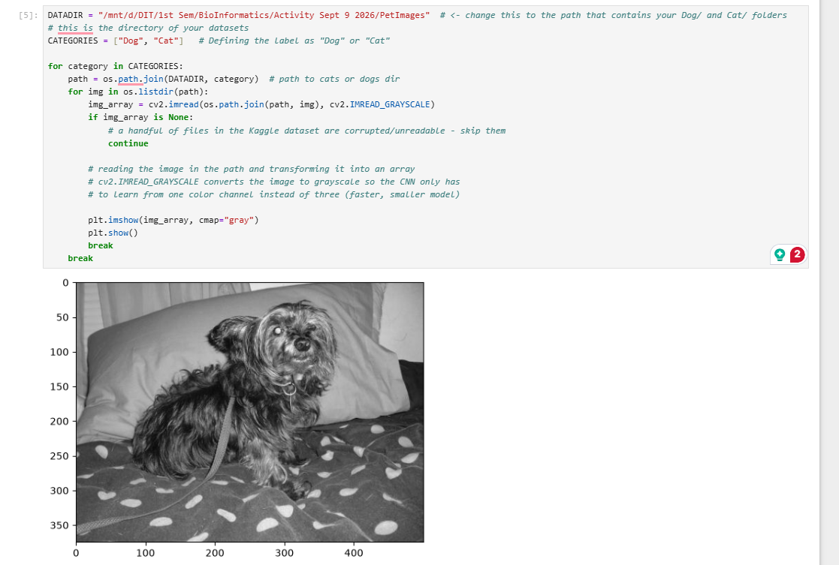

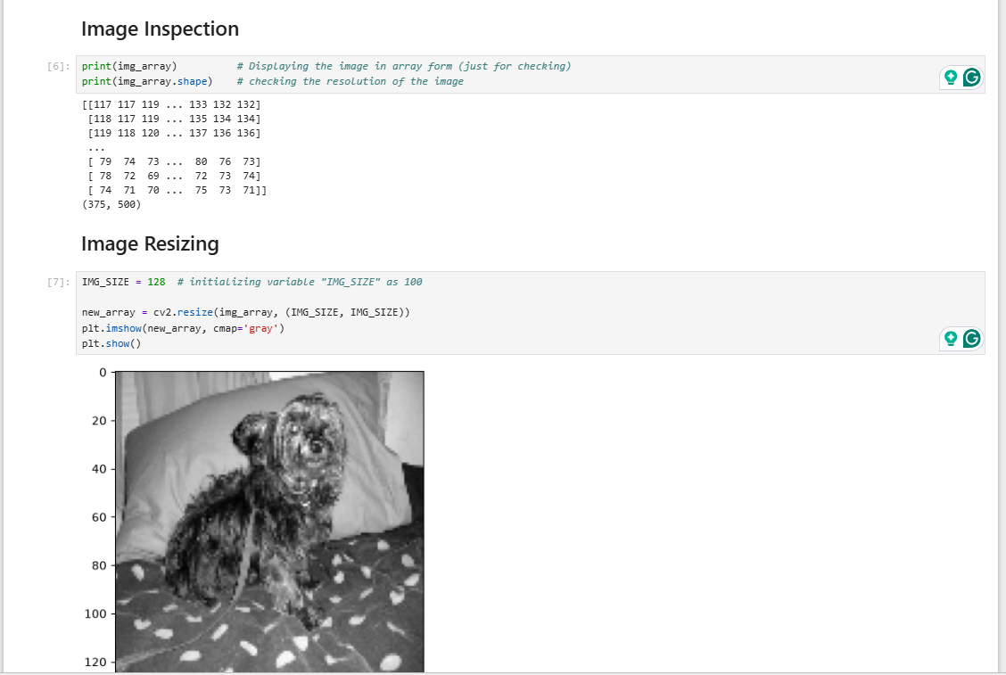

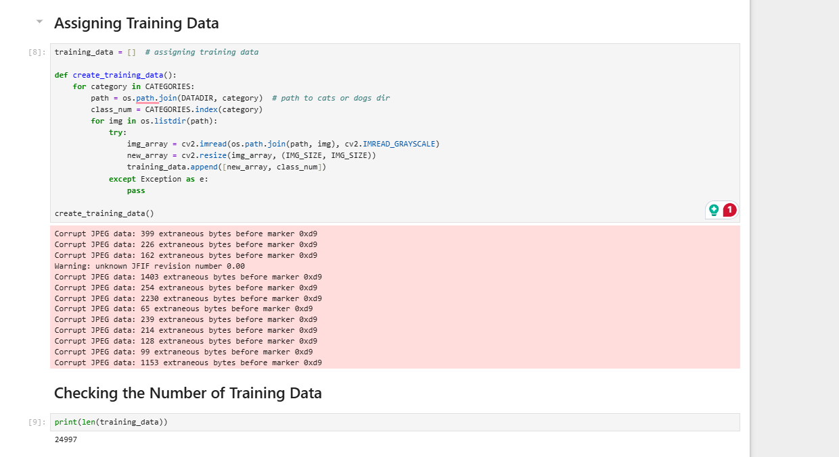
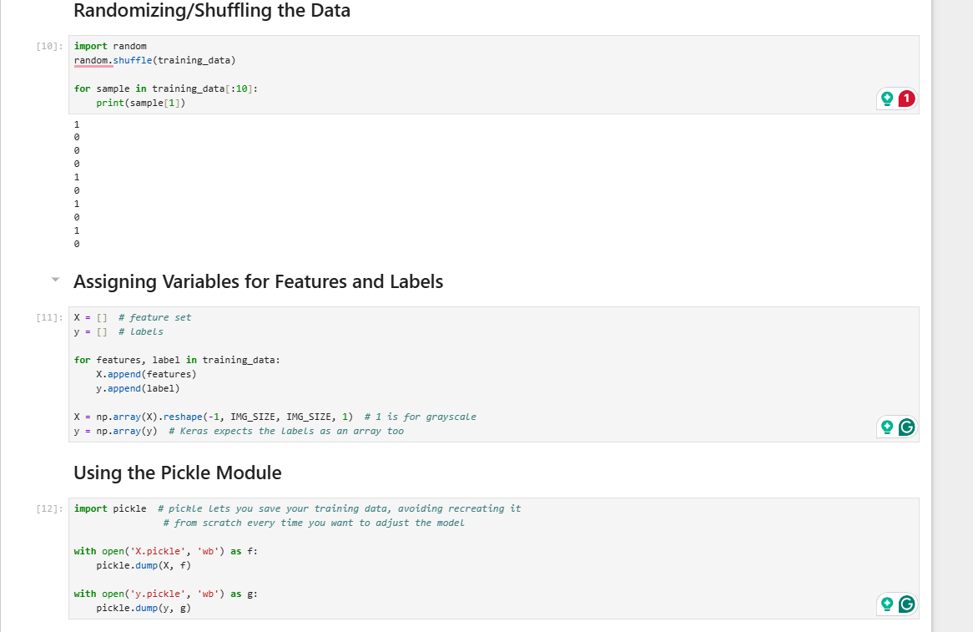

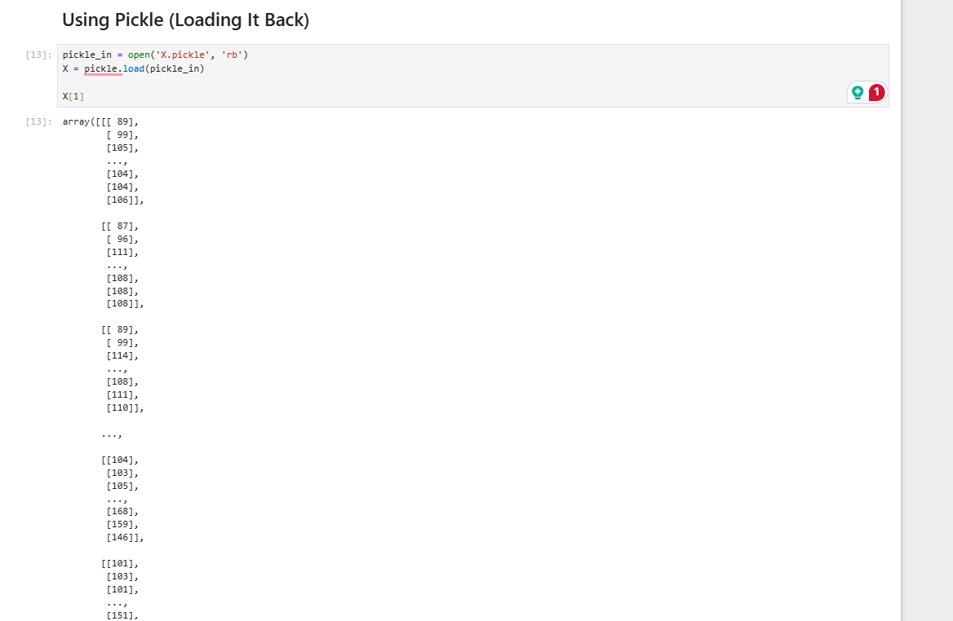

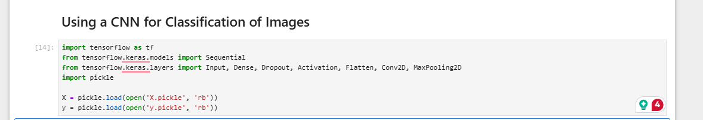

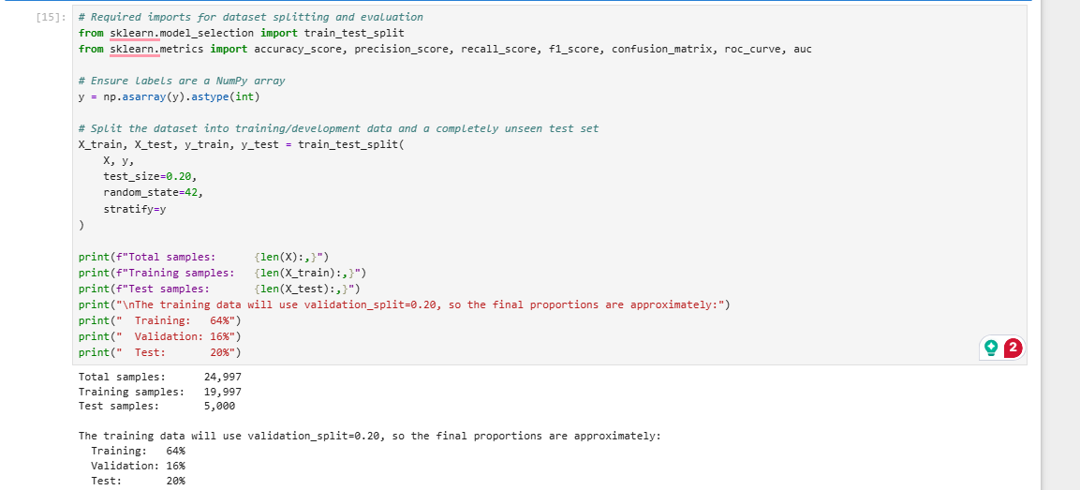

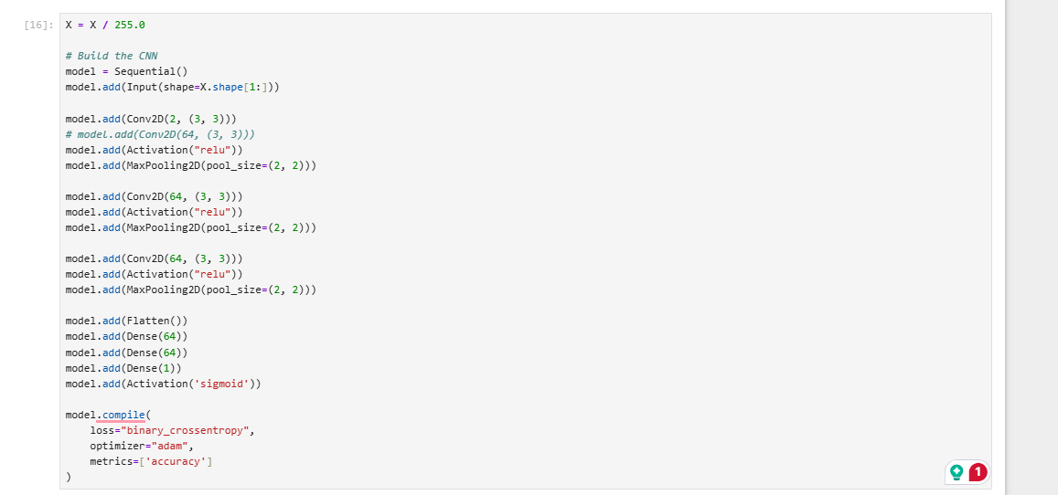

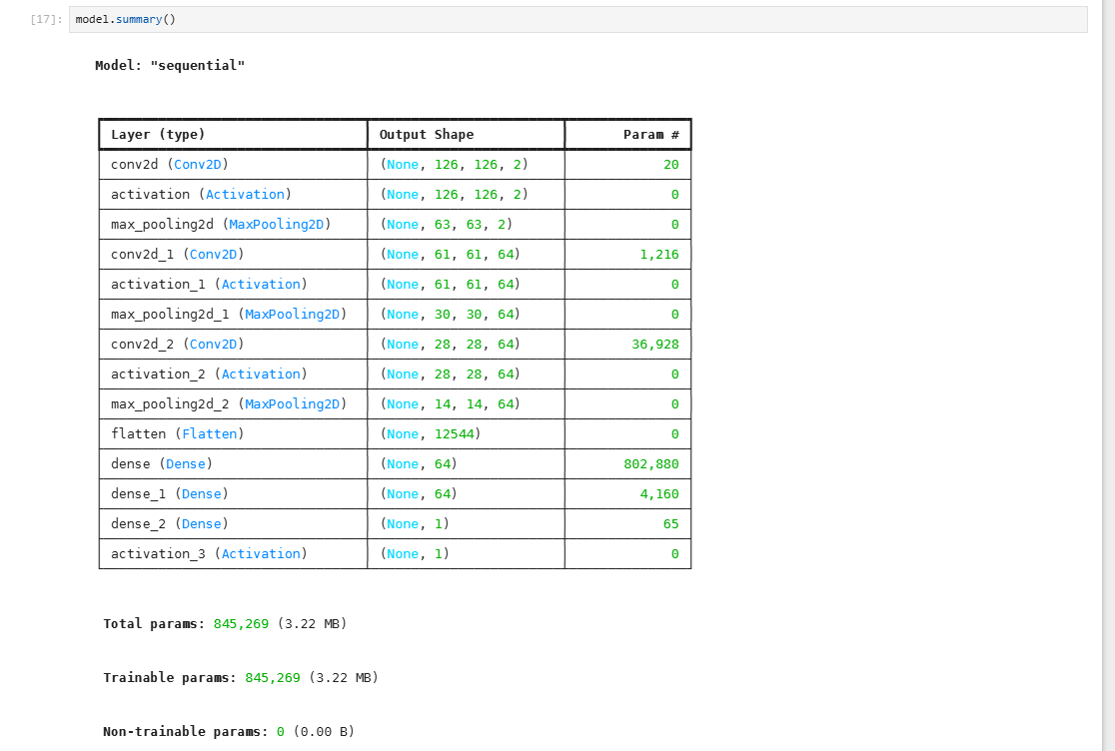

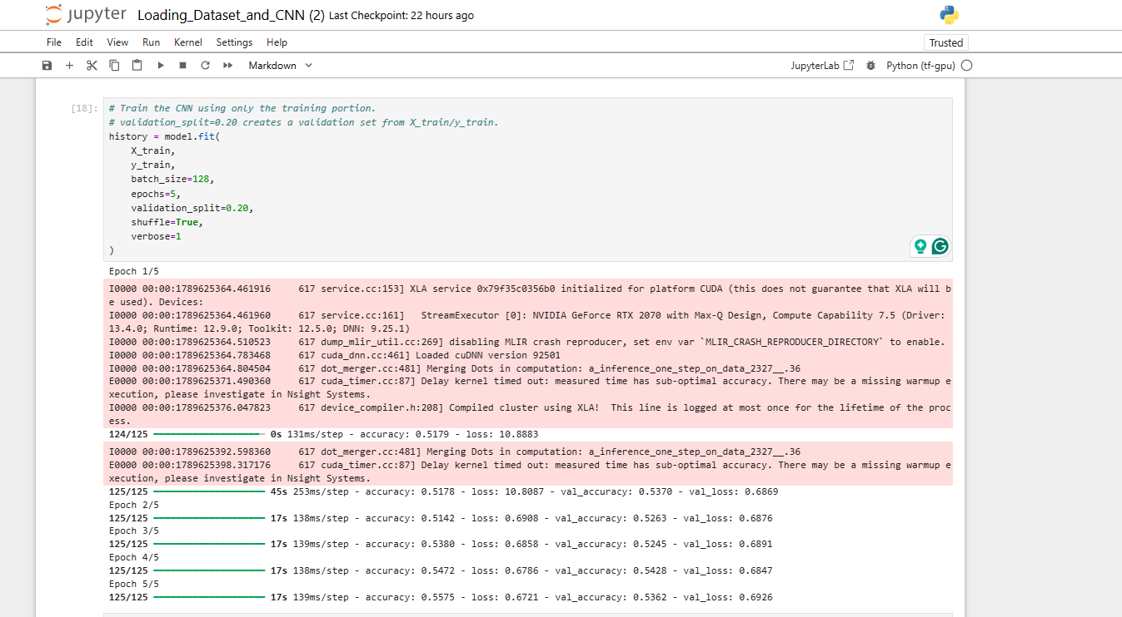

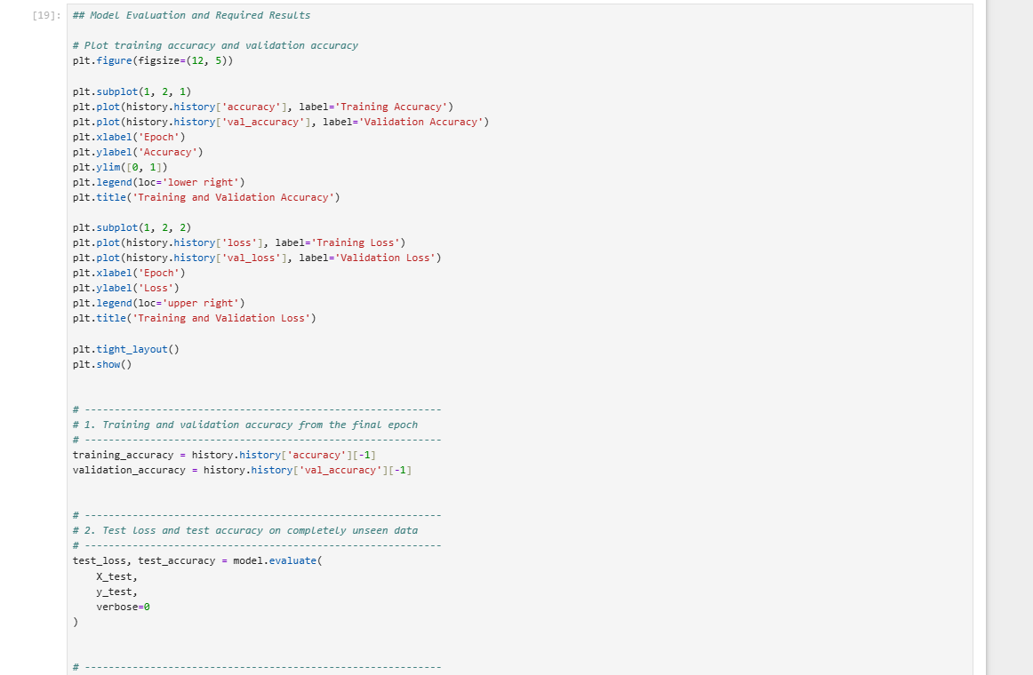

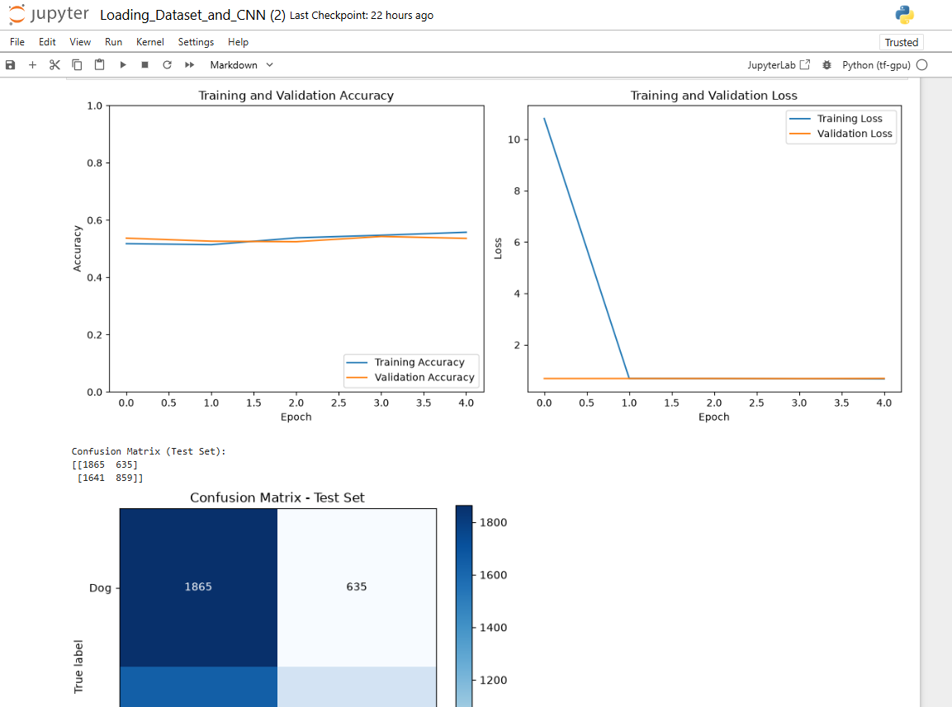
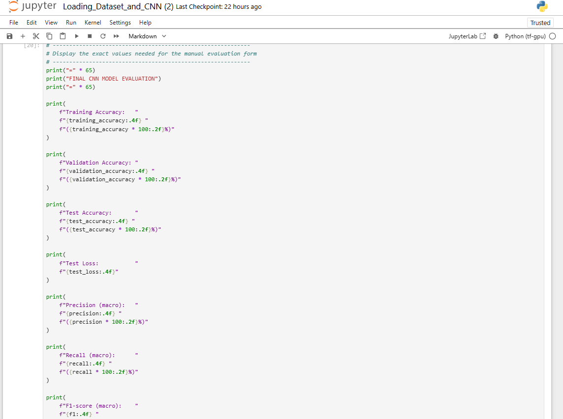

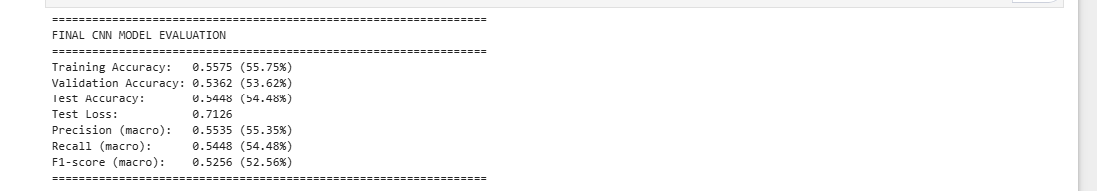

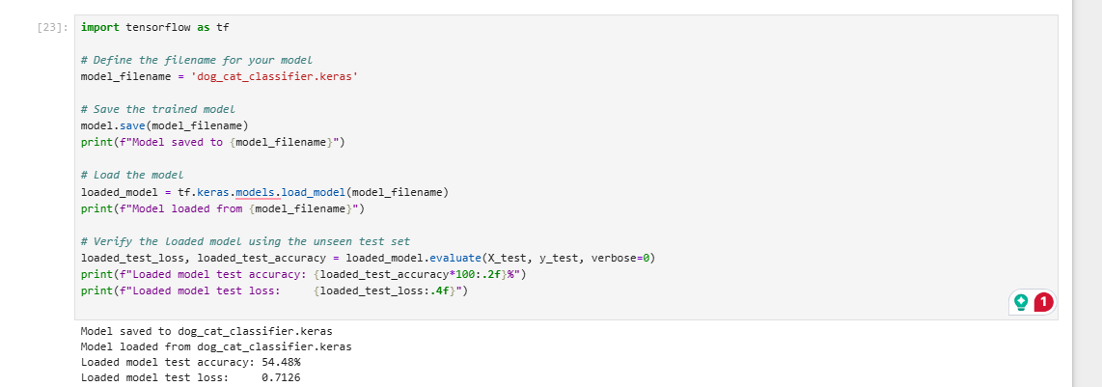
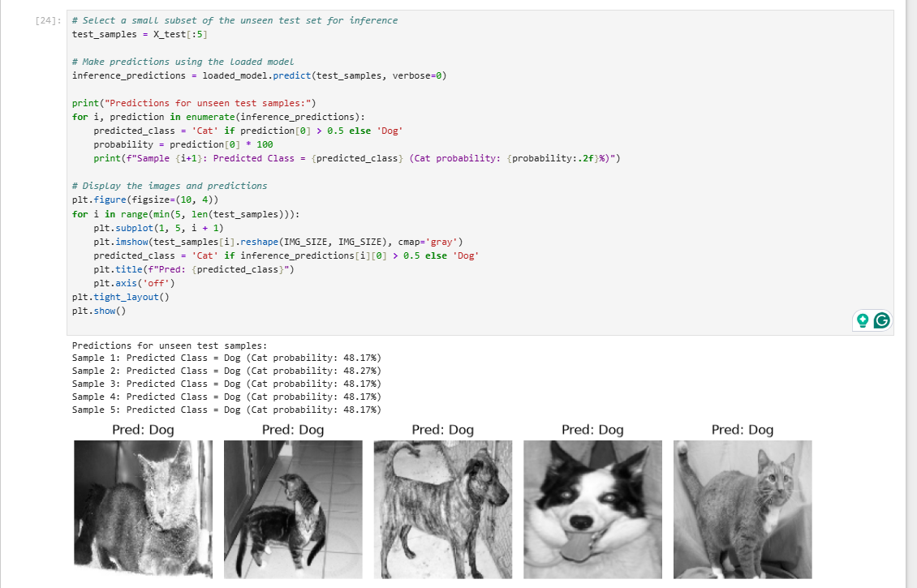

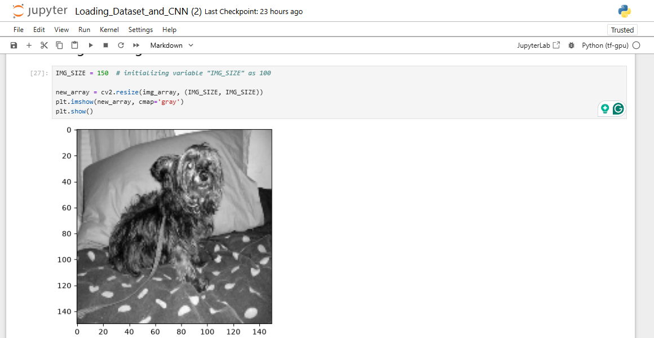
Trial 2: localhost run

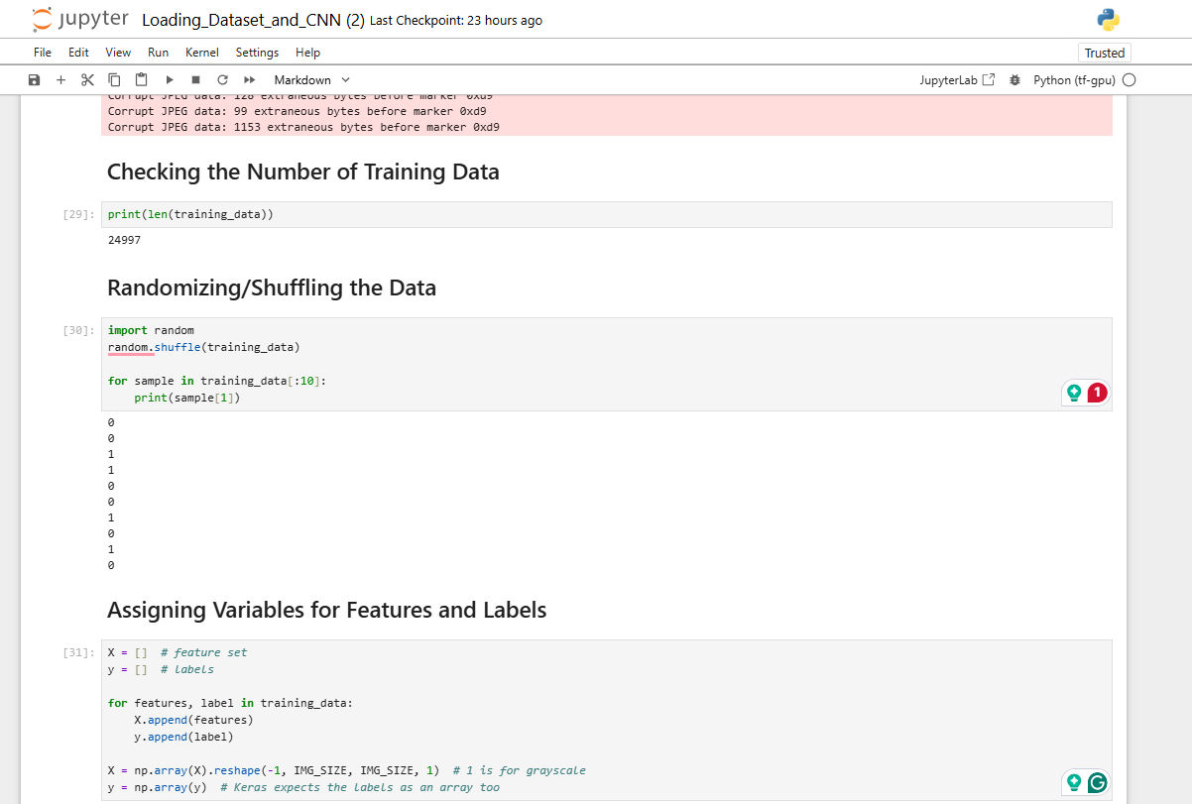
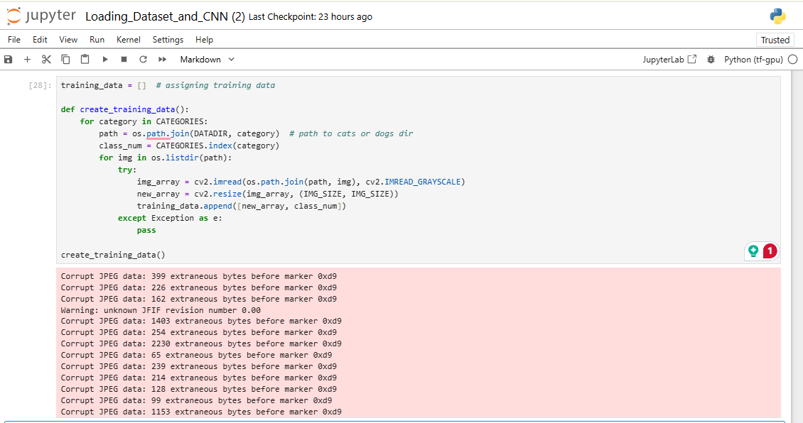
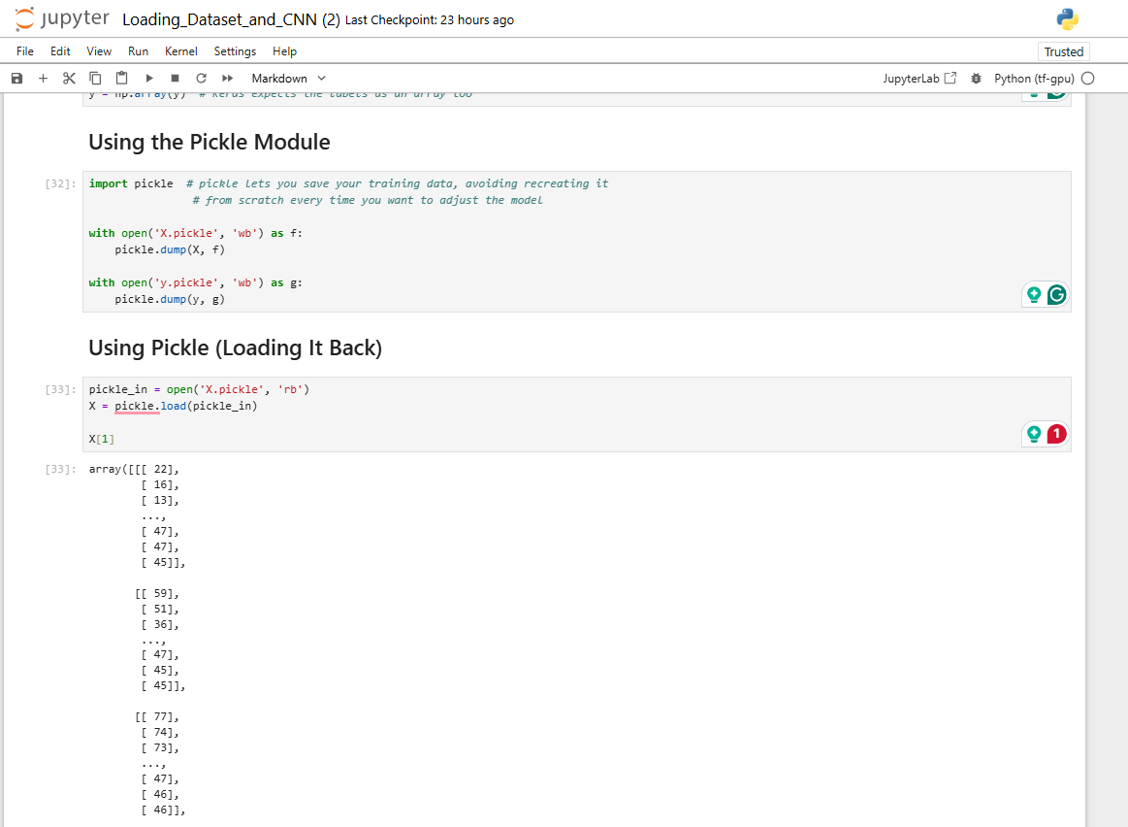

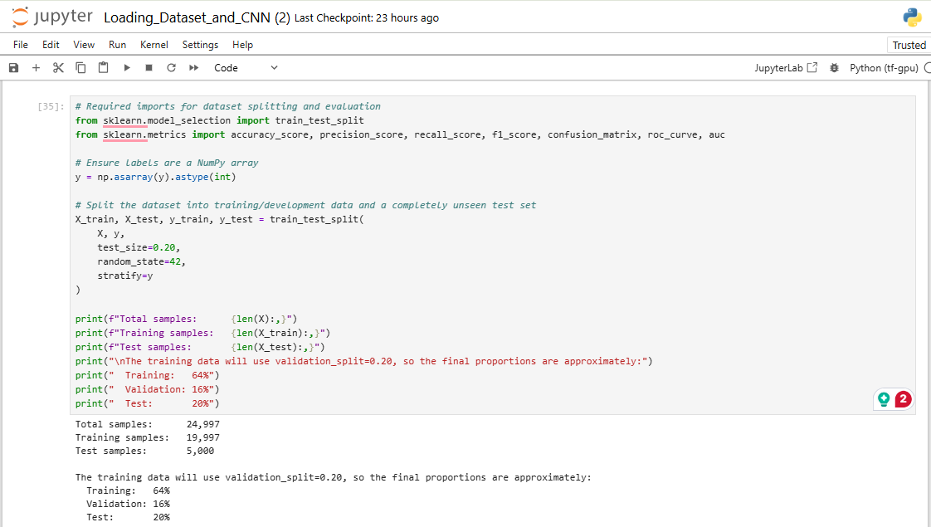

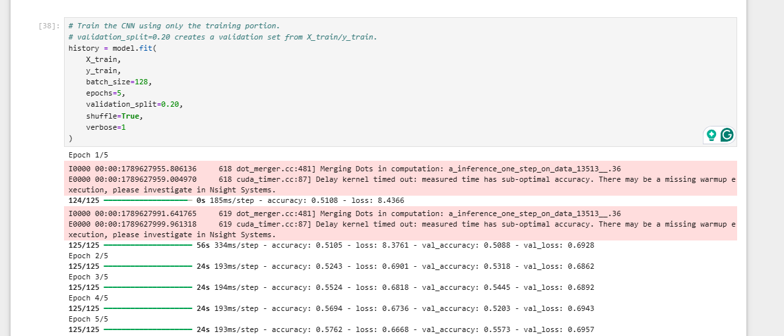
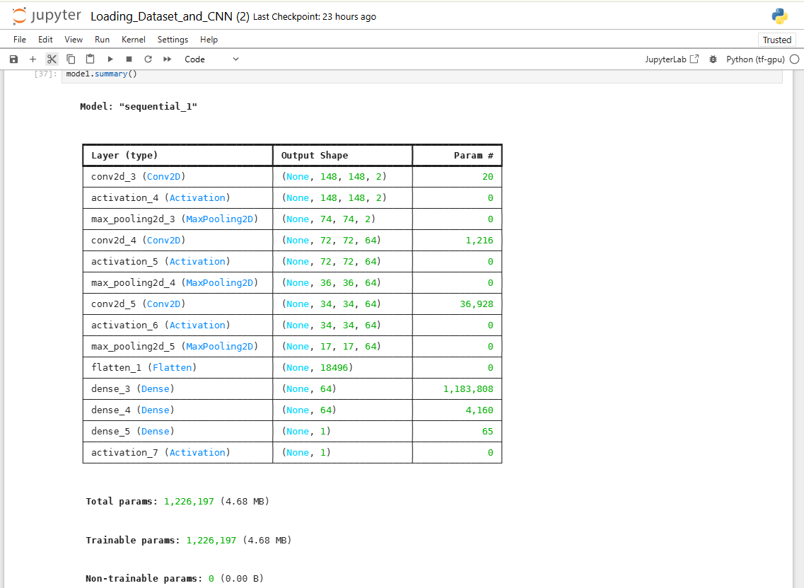

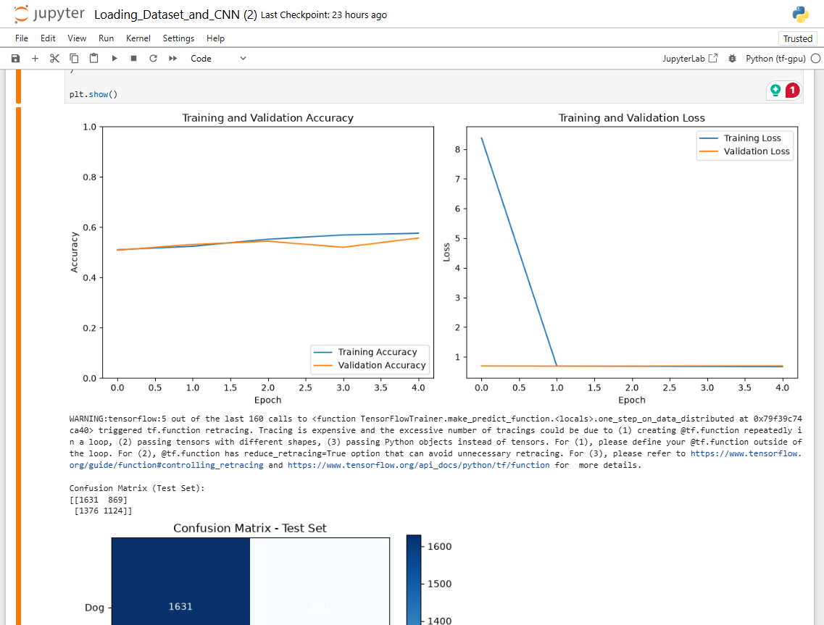

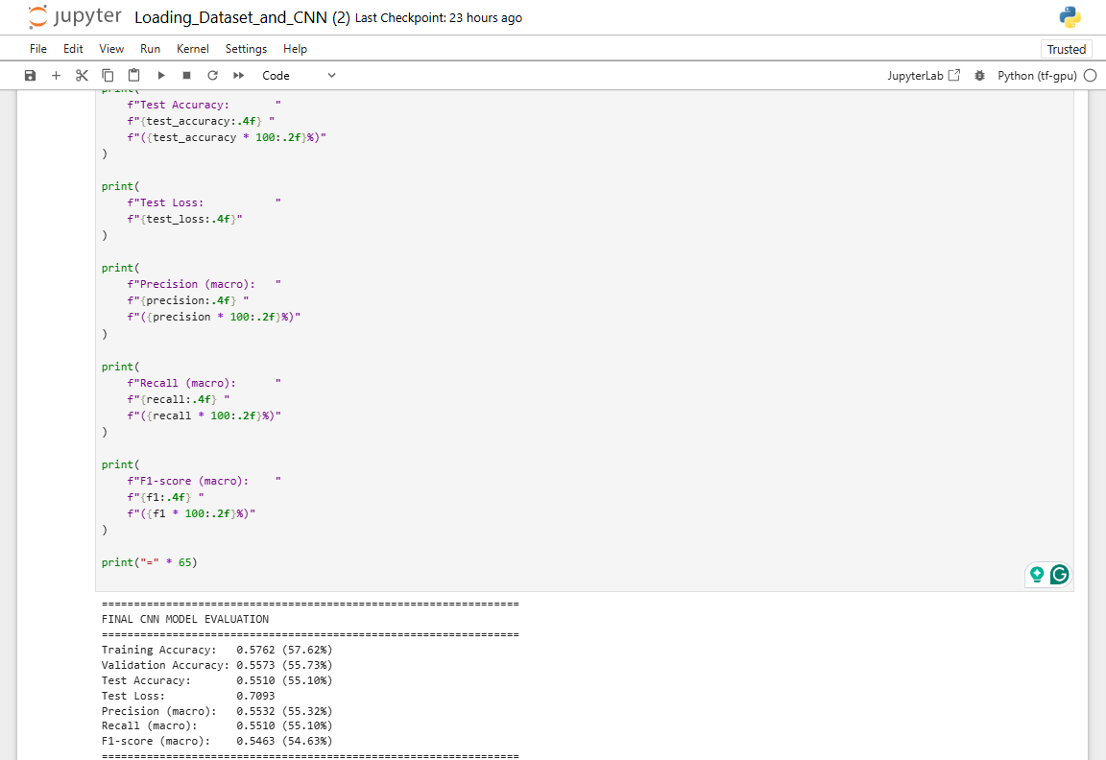

Trial 3: localhost run
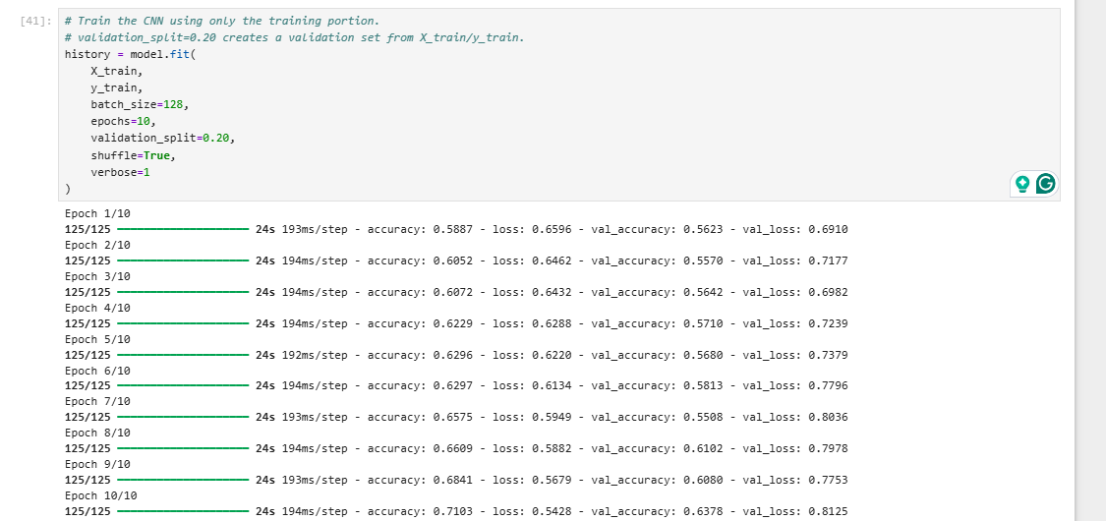

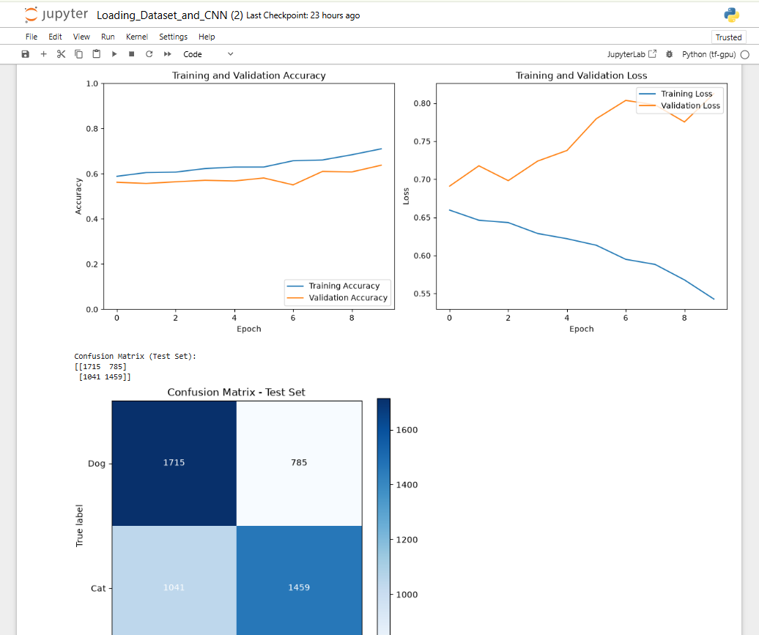

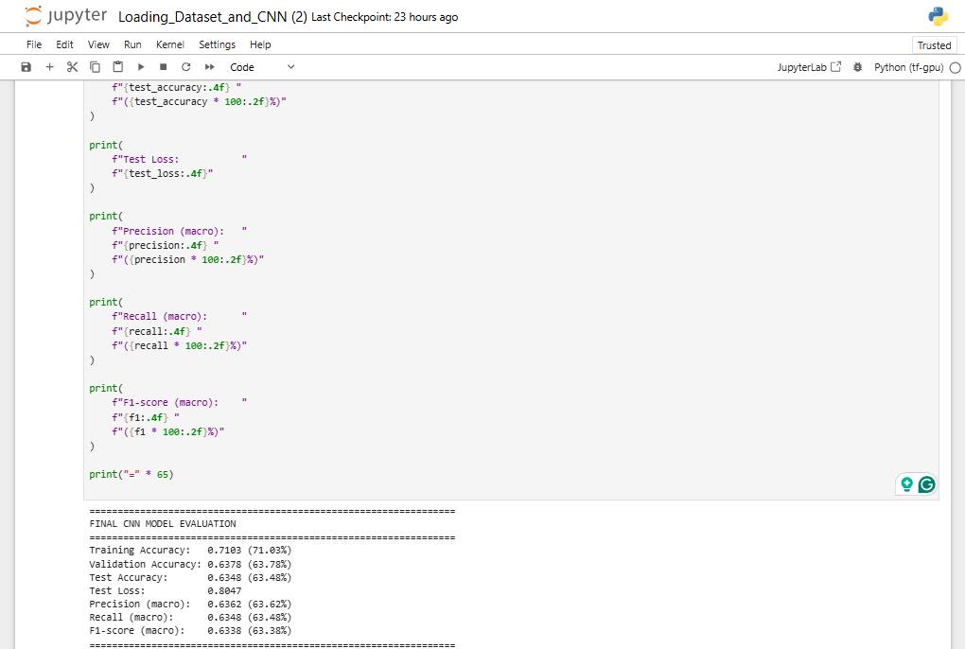
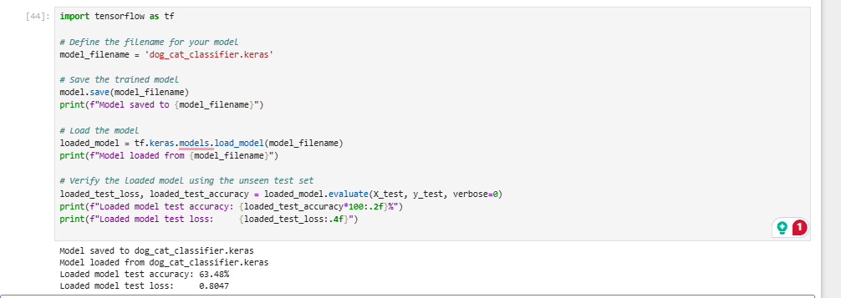
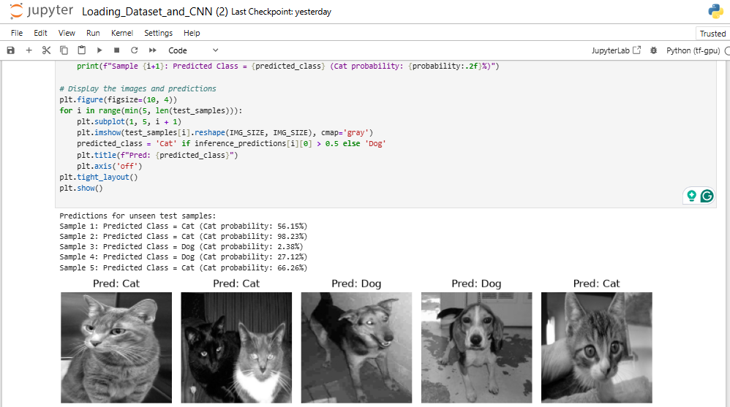

Trial 4: localhost run
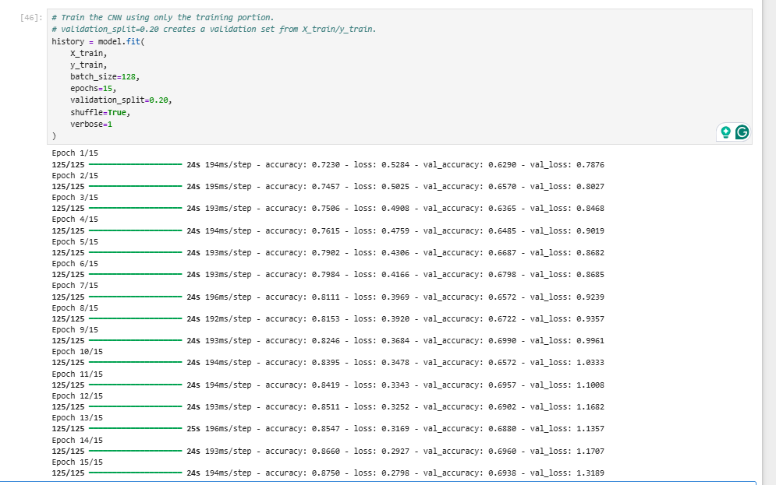
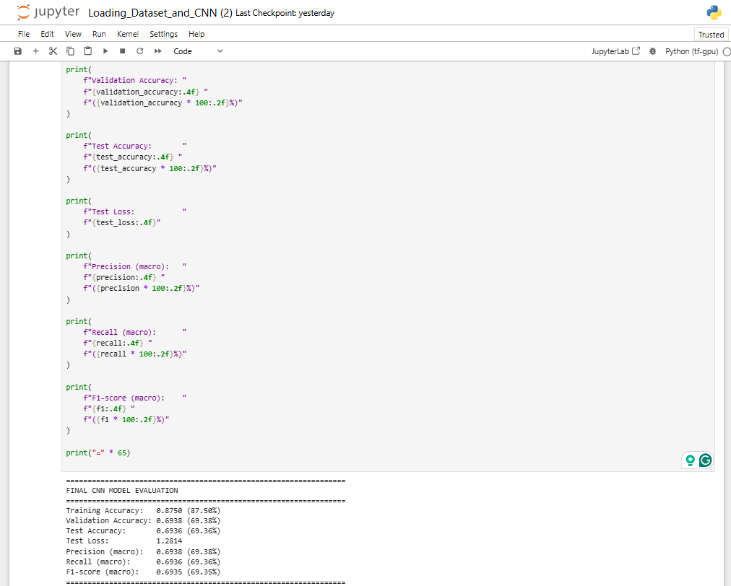
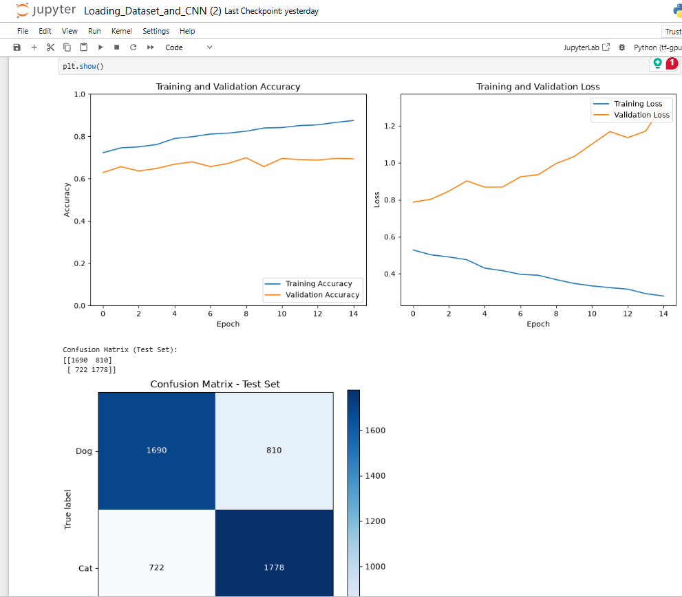

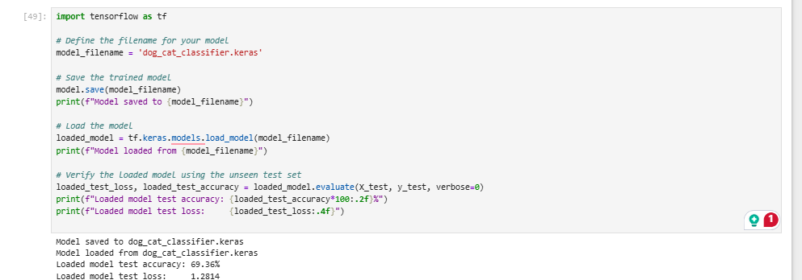
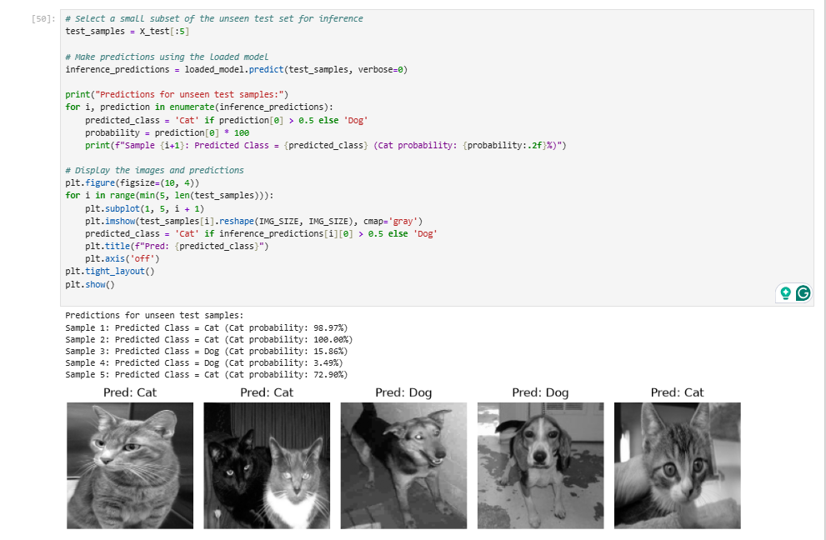

Trial 5: localhost run
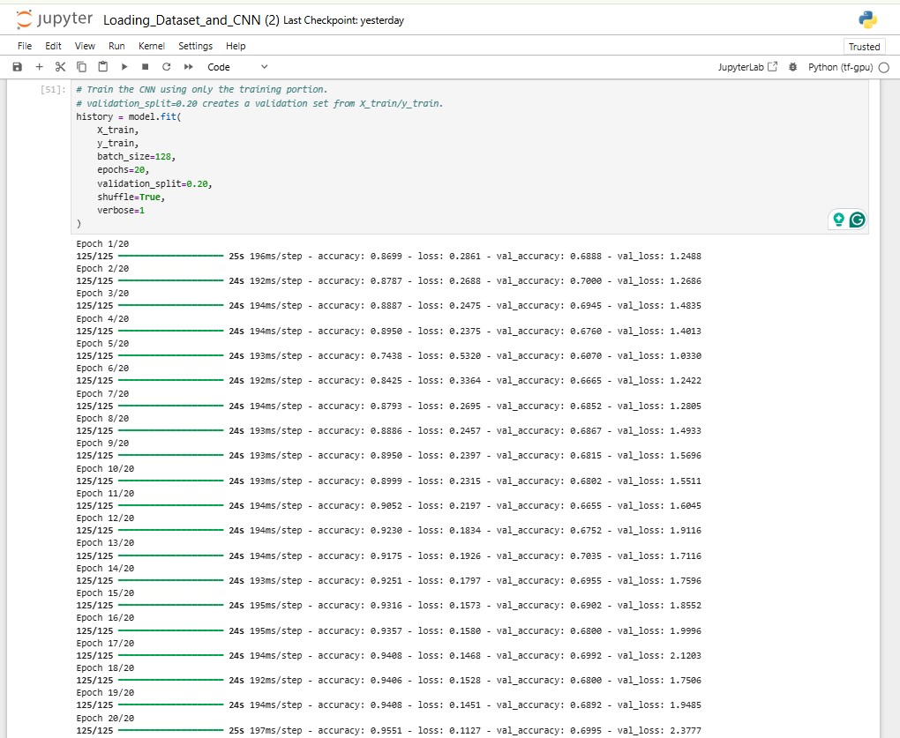

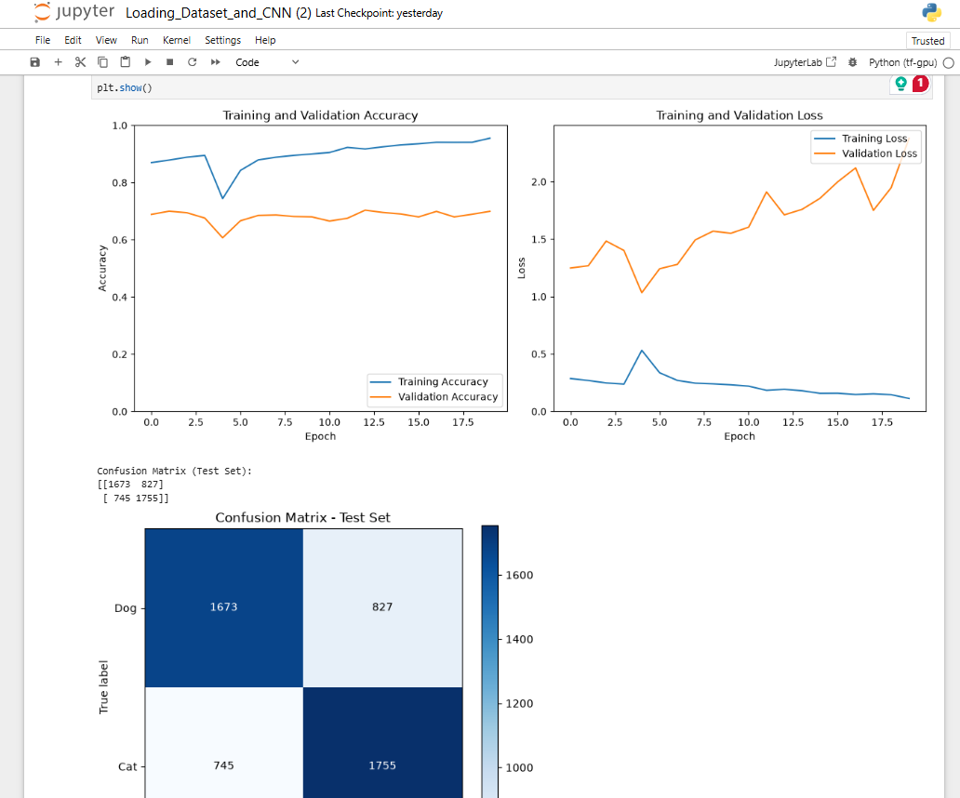

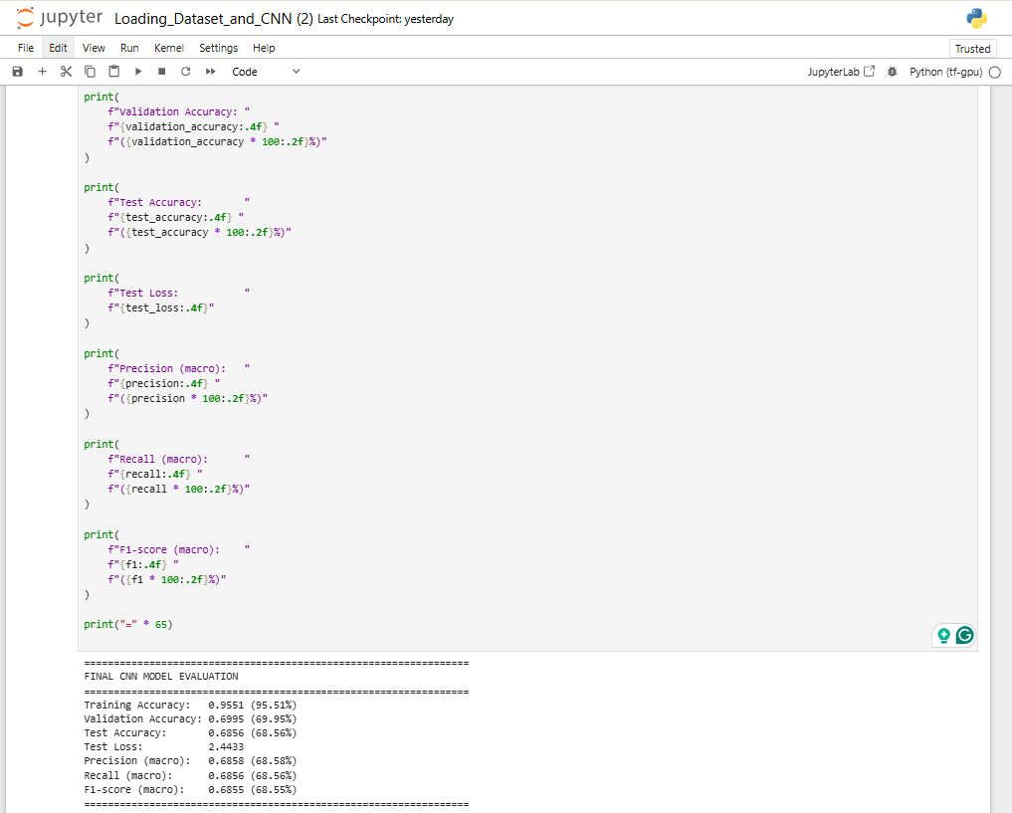

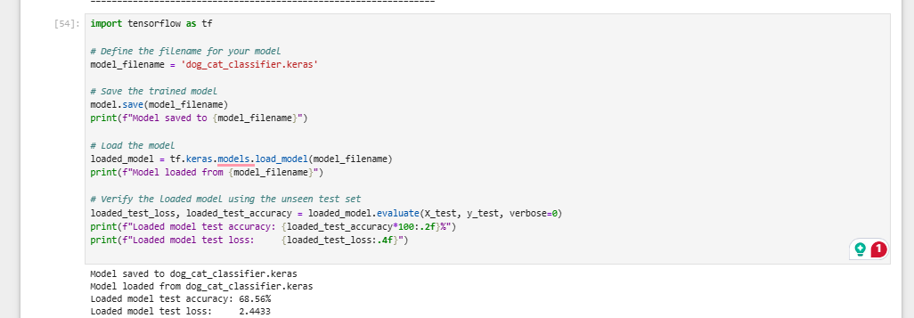

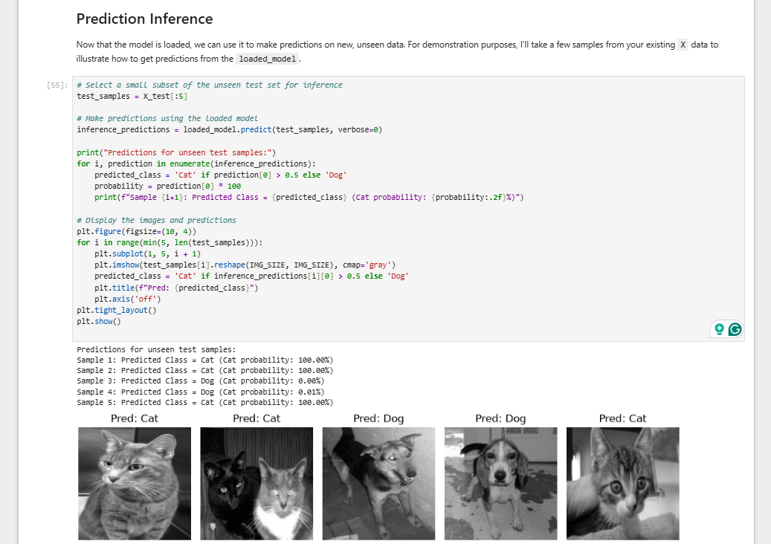

6. Overall Justification / Remarks
Summarize why this combination of hyperparameters was chosen (e.g., prior trial results, literature basis, computational constraints) and any observations (overfitting, underfitting, convergence issues).
The selected hyperparameters were based primarily on the results of five controlled trials while keeping most preprocessing and model architecture parameters constant. The image size was initially increased from 128 to 150 pixels to provide the CNN with a higher-resolution input while retaining the same grayscale conversion, pixel normalization (X/255.0), shuffling, validation split, CNN architecture, loss function, optimizer, learning rate, and batch size. The CNN used 64 filters in the first convolutional layer, a (3,3) kernel, ReLU activation, MaxPooling2D with a (2,2) pool size, 64 Dense units, no Dropout, and sigmoid activation for binary classification. Training used binary cross-entropy with Adam, a learning rate of 0.001, and a batch size of 128.

The number of epochs was progressively increased from 5 to 20. Training accuracy improved from 0.5575 in Trial 1 to 0.9551 in Trial 5, while validation accuracy increased from 0.5362 to 0.6995. Test accuracy similarly improved from 0.5448 to 0.6936 at Trial 4, but decreased slightly to 0.6856 in Trial 5. At the same time, test loss increased substantially from 0.7126 in Trial 1 to 1.2814 in Trial 4 and 2.4433 in Trial 5. These results indicate that increasing the training duration initially improved learning and generalization, but continued training eventually caused the model to fit the training data more closely without producing corresponding improvements on unseen data.

Trial 4, with 15 epochs, showed a relatively strong balance between training and validation performance, achieving 0.8750 training accuracy, 0.6938 validation accuracy, and 0.6936 test accuracy, with macro F1-score of 0.6935. Trial 5 achieved higher training accuracy (0.9551) but lower validation and test accuracy and substantially higher test loss, providing evidence of overfitting. Therefore, the observations suggest that approximately 15 epochs provided a more appropriate training duration than 20 epochs under the tested configuration. No early stopping was used in these trials, so the model continued training for the full specified number of epochs.

